**FIFA PLAYER ANANLYSIS**

**Report**

The FIFA player analysis is done using **exploratory data analysis.** Itis an approach of analyzing data to summarize their main characteristics, often using statistical graphics and other data visualization methods. In this data analysis we have done a detailed approach towards the data set given in the link.

The data is upright to fulfill the required data processing for the players in FIFA using python programming language.

Visualizations are done using required packages present in python, like python pandas library, numpy, seaborn and matplotlib etc.

The coding part is done by following steps:

* Read the csv file into a pandas dataframe.

* Generate some statistics on the height column. The values are given as strings so we will want to convert them to a number we can use in calculations

* Generate a histogram

* Match those data values to their respective positions

* Displaying part.

**Sample bar chart**

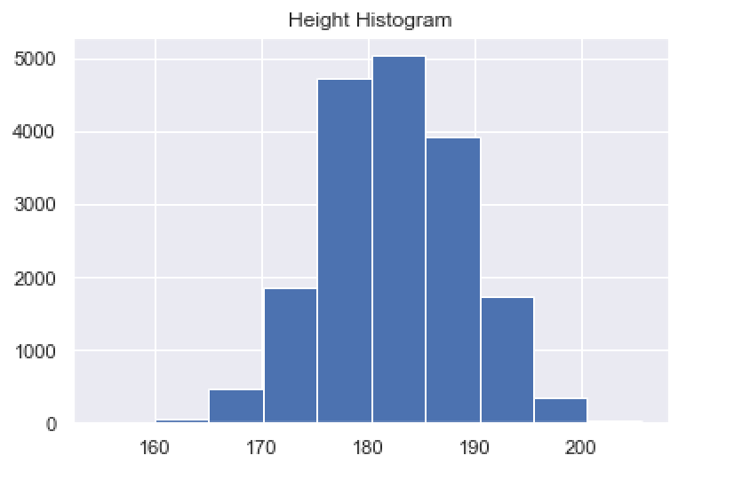

Sample Heat map

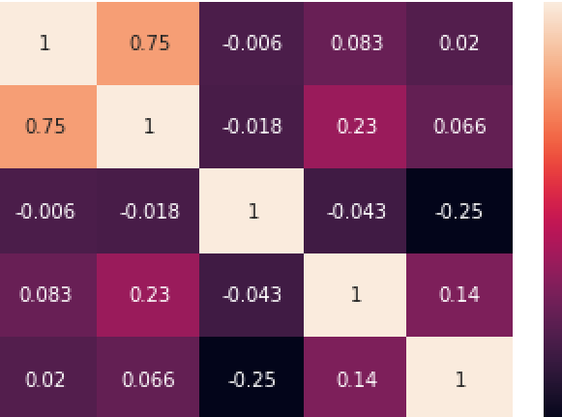



BY,

SRI RAM KARTHI P

RUTUJA

BIBINUS DE BOSCO

**MACHINE LEARNING WITH PYTHON**